AD8495 Thermocouple Amplifier
Date: | 08/01/14 | Version: | 1.0 | By: | Matt Little

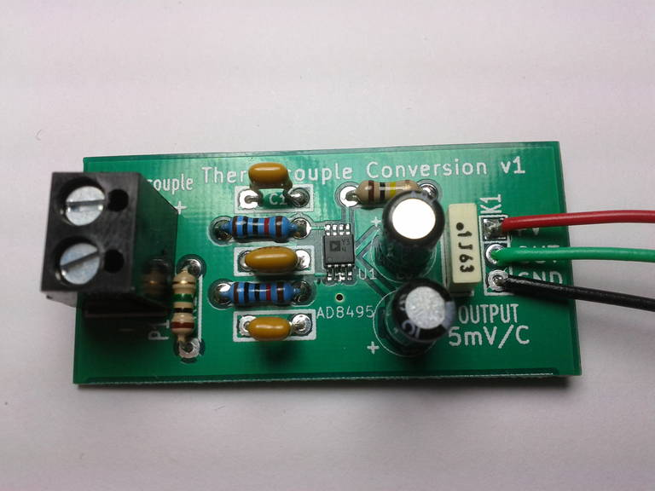 | This Thermocouple Amplifier Kit is based upon the AD8495 precision K-type thermocouple amplifier.  This can be used to measure very high temperatures, with a range up to 1000C (depending upon the rating of the thermocouple). The output is a voltage equal to 5mV per degree with a linear scale. This makes it very easy to measure with an analog input to a microcontroller (such as the Arduino).  Note: No thermocouple probe is included in this kit – please purchase separately for your application.

Data sheet for the AD8495 is available here:
http://www.analog.com/static/imported-files/data_sheets/AD8494_8495_8496_8497.pdf

Parts included:
 |  |  |  | 2 x 1nf Capacitor | 100nf  Capacitor | 10nf Capacitor
 | 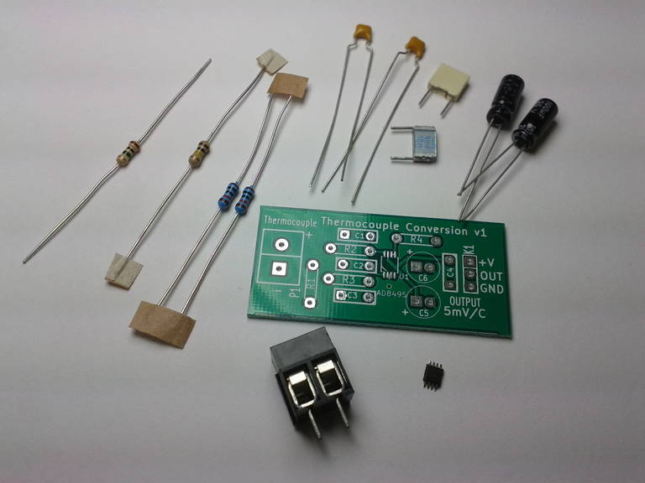
1uf
Capacitor
Resistors:
2 x 10k
1 x 100k
1 x 1M
 |  |  |  |  |  |  |  | 100uf Capacitor
 |  |  |  | 2 Way Terminal |  | AD4895  SMD IC |  | PCB

Parts list:

Ref | Value and description
C1 | 1nf capacitor
C2 | 10nf capacitor (might vary from photo)
C3 | 1nf capacitor
C4 | 100nf capacitor
C5 | 100uf capacitor
C6 | 1uf capacitor
K1 | DATA – Solder pads
P1 | Thermocouple – Screw terminals for the therm
R1 | 1M resistor
R2 | 10k resistor
R3 | 10k resistor
R4 | 100k resistor
U1 | AD8495 SMD K-type Termocouple Amplifier

Tools required:
 | 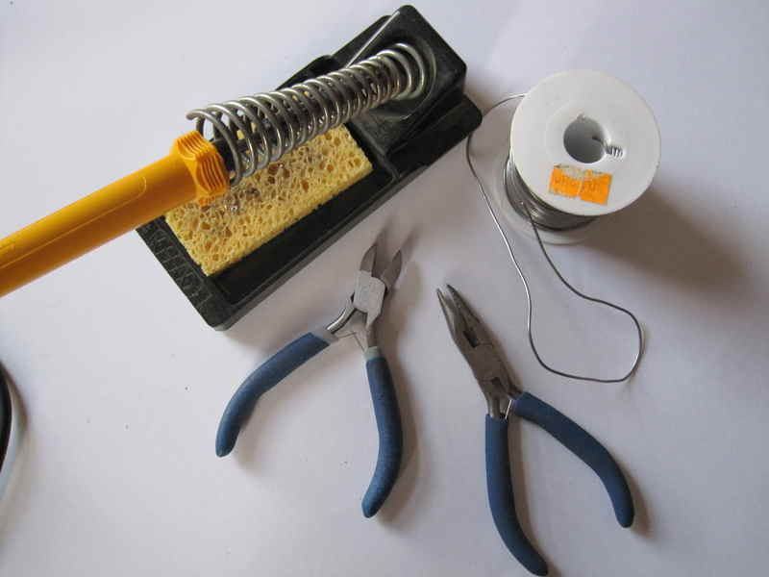
Soldering Iron
 |  |  |  |  |  |  |  | Solder
Side cutters |  |  |  |  |  |  |  | Small nosed pliers

Instructions:
Step: 1 | Solder the SMD IC AD8495
Lets start with probably the most difficult soldering step. Its best to do this first, or the other components get in the way.  Holding the IC with a pair of tweezers align over the solder pads.  Ensure the correct orientation – the dot on the IC will be at the end with the triangle on the PCB.  Solder one pin on the corner of the IC. Ensure that the IC lines up with all the other pads. If you need to adjust it then heat the solder on the soldered pin and correct the IC.  Once it is aligned then you can solder the whole row of pins on the other side to the already soldered pin.  If you heat up the top pin and apply solder then drag down to the bottom pin, applying solder if required. This usually will solder all the pins. You may need to remove any excess solder using some solder wick.  Leave this to cool for a couple of seconds.  Then use the same technique for the un-soldered side. |  | 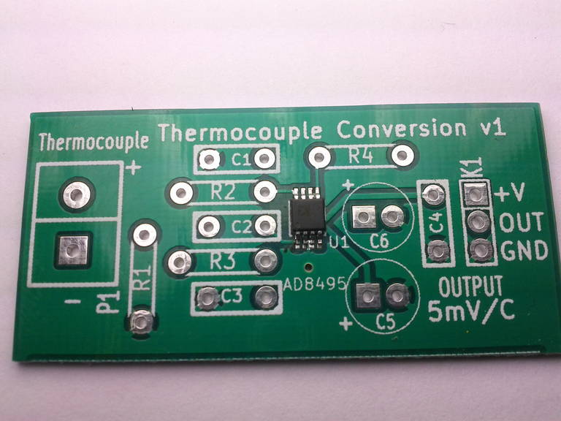

Step: 2 | Solder the resistors
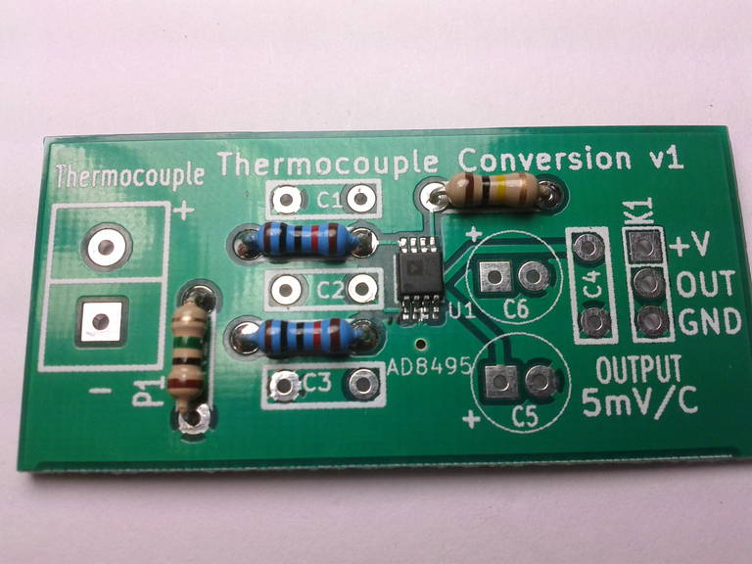 |  | Identify all the resistors. You will have:  Use the identify chart at the end of these instructions or a multimeter.  Solder into the relevant places.  Their orientation does not matter.
  Quantity | Value | Part Reference
  1 | 1M | R1
  2 | 10k | R2,R3
  1 | 100k | R4

Step: 3 | Solder the Capacitors
Identify and then solder in the capacitors.  Capacitors C1-4 can be installed in either direction.  Check the orientation on capacitors C5,C6. The white line on the side signifies negative side. The round pad on the PCB signifies negative. The longer lead signifies positive. The square pad on the PCB is positive. |  | 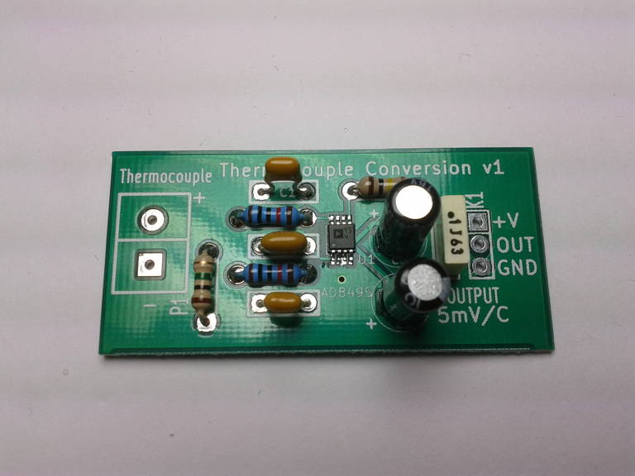
  Quantity | Value | Reference | Photo
  2 | 1nf | C1, C3 | 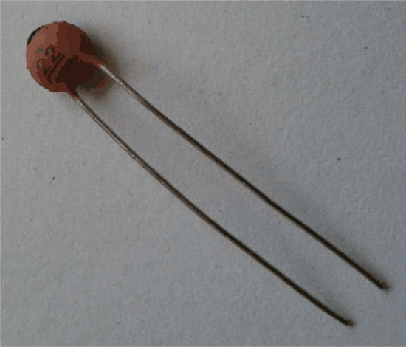
  1 | 10nf | C2
  1 | 100nf | C4 | 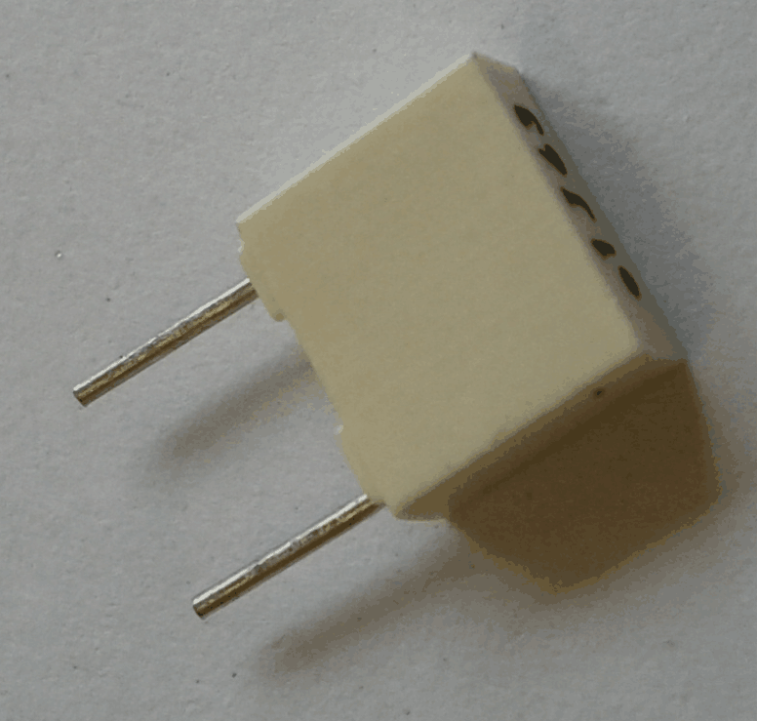
  1 | 100uf | C5 | 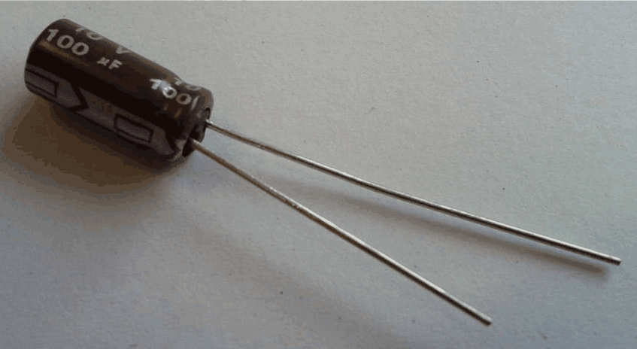
  1 | 1uf | C6

Step: 4 | Solder the screw terminal block
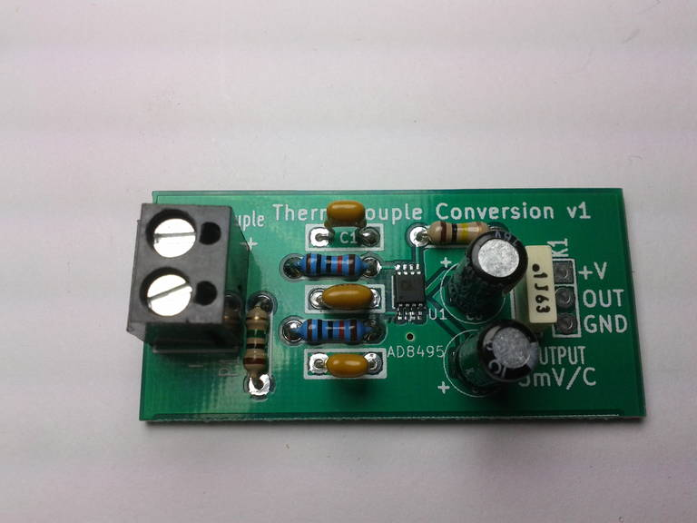 |  | This will be used to connect the thermocouple wires.

Step: 5 | Build is finished!
Have a nice cup of tea. |  | 

Step: 6 | Test the device
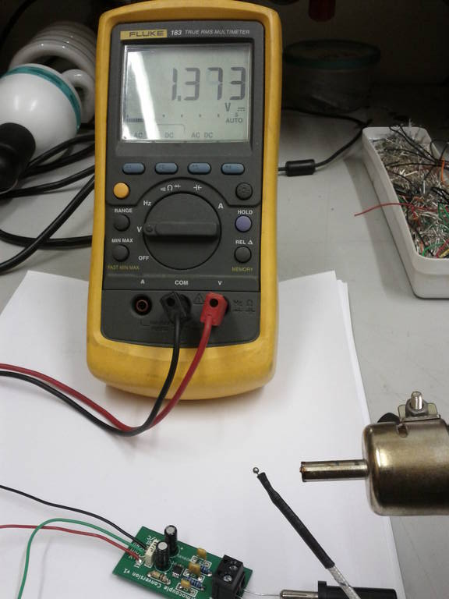 |  | To test the device, connect a k-type thermocouple to the screw terminals.  Apply 5V power supply to the V+ pin and GND. Measure the output with a multimeter.  The output should be +5mV per degree C.  In this photo I have heated the thermocouple with a hot air gun and am getting a reading of 1.373V, which equates to:  1.373V / 0.005 = 274C  The error is +/-2C for the range 25C-400C.  Note: This version cannot measure below zero (but check the data sheet for an application note to do this).
Contact details:
This kit has been designed and produced by:
Renewable Energy Innovation.
info@re-innovation.co.uk
www.re-innovation.co.uk
Hopkinson Gallery
21 Station Street
Nottingham
NG7 6PD

We would like you to be happy with this kit. If you are not happy for any reason then please contact us and we can help to sort it out. Please email info@re-innovation.co.uk with any questions or comments.
If any parts are missing from your kit then please email info@re-innovation.co.uk with details, including where the kit was purchased.

More technical information can be found via www.re-innovation.co.uk.

Useful Information:
Resistor colour codes:

Circuit schematic:
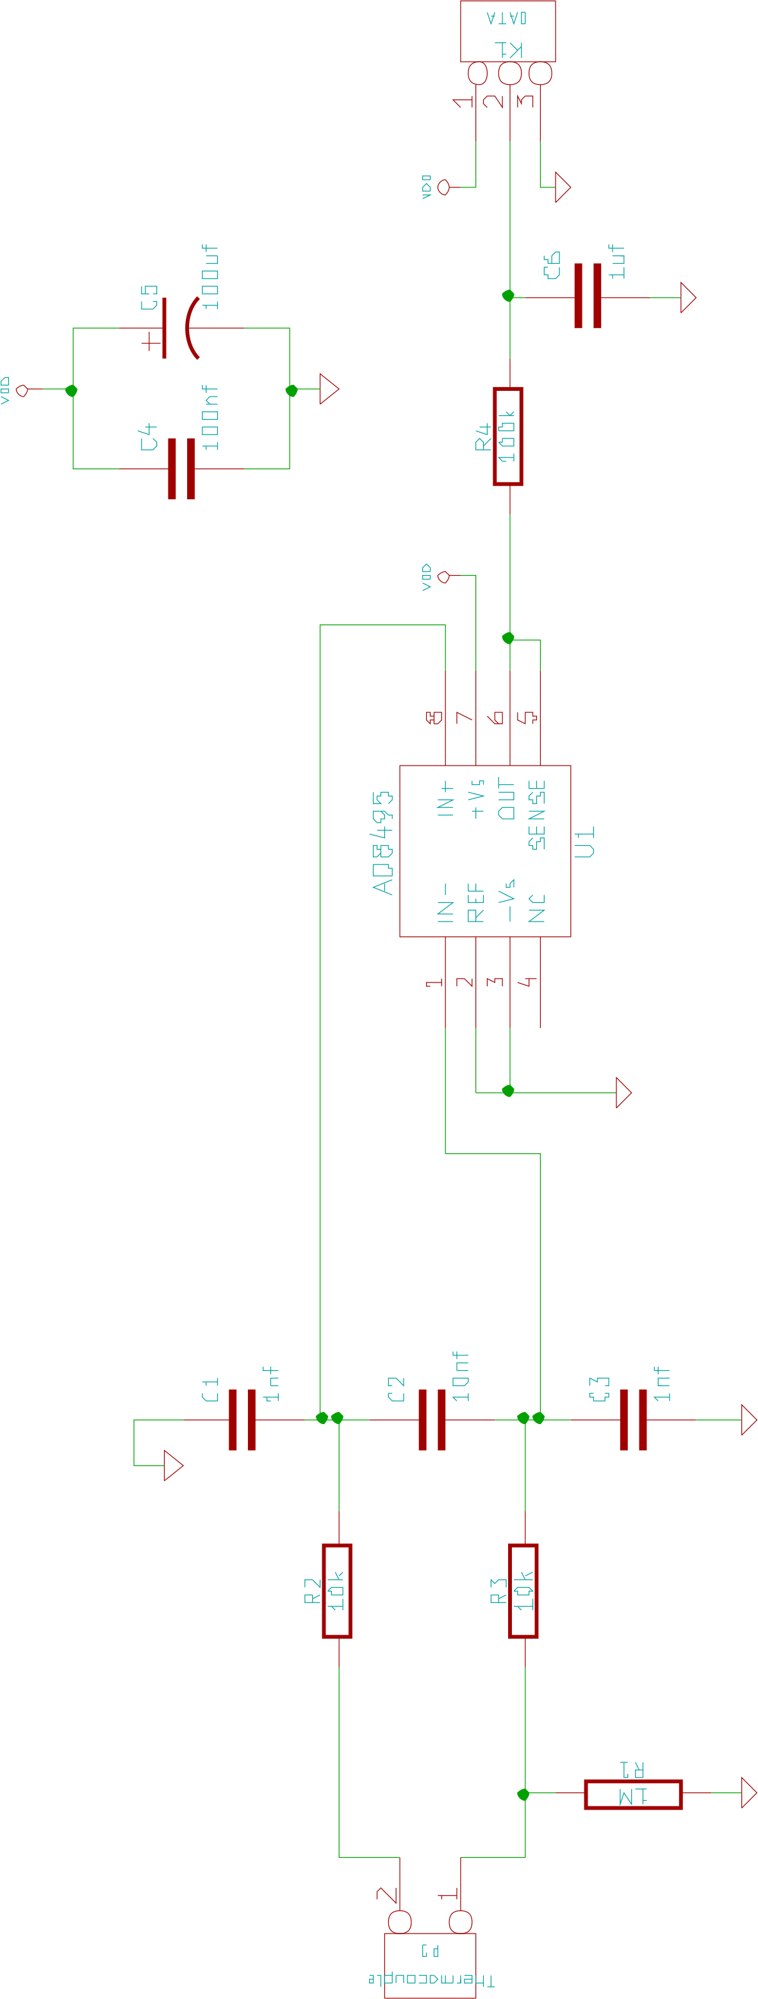

PCB overview:

